VV COLLEGE OF engineering

TISAIYANVILLAI

Iot based safety gadget for child safety

A project report submitted by

Team leader:sugi.l

Team members:

1.sangeetha.r

2.saraswathi vidya.v

3.shobisha.l

4.suji.l

In partial fulfillment for the award of degree of bachelor of engineering(B.E) in ELECTRONICS AND COMMUNICATION ENGINEERING at VV COLLEGE OF ENGINEERING, TISAIYANVILLAI.

ACKNOWLEDGEMENT

We would like to express our special thanks to gratitude to our faculty mentor and industry mentor for their support and guidance in completing our project on the smart fashion recommender application.

We would like to extend our gratitude to the ibm for nalaiya thiran project for providing us with all the facility that was required.

It was a great learning experience.We would like to take this opportunity to express our gratitude.

TITLE

**1.INTRODUCTION**

* 1. Project Overview
  2. Purpose

1. **LITERATURE SURVEY**
   1. Existing problem
   2. References
   3. Problem Statement Definition

**IDEATION & PROPOSED SOLUTION**

* 1. Empathy Map Canvas
  2. Ideation & Brainstorming
  3. Proposed Solution
  4. Problem Solution fit

1. **REQUIREMENT ANALYSIS**
   1. Functional requirement
2. **PROJECT DESIGN**
   1. Data Flow Diagrams
   2. Solution & Technical Architecture
   3. User Stories
3. **PROJECT PLANNING & SCHEDULING**
   1. Sprint Planning & Estimation
   2. Sprint Delivery Schedule
   3. Reports from JIRA
4. **CODING & SOLUTIONING (Explain the features added in the project along with code)**
   1. Feature 1
   2. Feature 2
   3. Database Schema (if Applicable)
5. **TESTING** 
   1. Test Cases
   2. User Acceptance Testing
6. **RESULTS**
   1. Performance Metrics

9.**AdVANTAGES & DISADVANTAGES**

**10.CONCLUSION**

**11.FUTURE SCOPE**

**12.APPENDIX**

Abstract

The overall percentage of child missing nowadays in the world is about 80%, out of which 74% are girl children and the rest are boys. For every 40 seconds, a child goes missing in this world.

Children are the backbone of one's nation, if the future of children was affected, it would impact the entire growth of that nation.

Due to the emotional and mental stability of the children gets affected which in turn ruins their career and future.

These innocent children are not responsible for what happens to them. So, parents are responsible for taking care of their own children.

But, due to economic condition and aims to focus on their child's future and career, parents are forced to crave for money. Hence, it becomes difficult to cling on to their children all the time.

In our system, we provide an environment where this problem can be resolved in an efficient manner.

It makes parents to easily monitor their children in real time just like staying beside them as well as focusing on their own career without any manual intervention. .

introduction

Internet of Things (IoT) plays a major role in every day to day life.

The major difference between IoT and embedded system is that a dedicated protocol/software is embedded in the chip in case of embedded system, whereas, IoT devices are smart devices, which are able to take decisions by sensing the environment around the device.

The development of sensors technology, availability of internet connected devices; data analysis algorithms make IoT devices to act smart in emergency situations without human interventions.

So, IoT devices are applied in different fields such as agriculture, medical, industrial, security and communication applications[1]. IoT systems are useful within a system to do deeper automation, analysis, integration.

IoT contributes to technology by advances in software, hardware and modern tools. It even uses existing and upcoming technology in the fields of sensing, networking and robotics.

IoT brings global changes by its advanced elements in the social, economic, and political impact of the users.

Enable tracking of the child’s location and capturing of data remotely such as temperature, pulse, respiratory rate, quality of sleep and many more.

To show the child's actual data with reference values.

2.literature survey

RFID-based System for School Children Transportation Safety Enhancement This paper presents a system to monitor pick-up/drop-off of school children to enhance the safety of children during daily transportation from and to school.

The system consists of two main units, a bus unit, and a school unit. The bus unit the system is used to detect when a child boards or leaves the bus.

This information is communicated to the school unit that identifies which of the children did not board or leave the bus and issues an alert message accordingly.

The system has a developed web-based database-driven application that facilities its management and provides useful information about the children to authorized personnel.

A complete prototype of the proposed system was implemented and tested to validate the system functionality. The results show that the system is promising for daily transportation safety. B.

Design and Development of an IOT based wearable device for the Safety and Security of women and girl children The aim of this work is to develop a wearable device for the safety and protection of women and girls.

This objective is achieved by the analysis of physiological signals in conjunction with body position. The physiological signals that are analyzed are galvanic skin resistance and body temperature.

Body position is determined by acquiring raw accelerometer data from a triple axis accelerometer. Acquisition of raw data is then followed by activity recognition which is a process of employing a specialized machine learning algorithm.

Real-time monitoring of data is achieved by wirelessly sending sensor data to an open source Cloud Platform. Analysis of the data is done on MATLAB simultaneously.

This device is programmed to continuously monitor the subject’s parameters and take action when any dangerous situation presents itself.

It does so by detecting the change in the monitored signals, following which appropriate action is taken by means of sending notifications/alerts to designated individuals.

2.1ideation & proposed solution

In the existing system, manual intervention was required. But in the proposed system, we make every action autonomously.

We can use both web application as well as mobile application or either one of it as the front end user interface, cloud, and database as the back end for storing and retrieving information, and a device for monitoring.

GPS is used to track the live location of the child who is wearing that device. With the help of GPS, we can easily perform Geo-fencing concept, in which we will be able to feed a particular boundary to that device.

If the child goes beyond that particular boundary specified, the respective guardians will receive an alert call using GSM. In our system, we use several components like, 1.Temperature sensor

2.Pulse sensor

3.GPS

4.GSM

5.Web camera

6. Raspberry pi microprocessor

The Temperature sensor is used to sense the surrounding temperature of the device. If the temperature level exceeds the room temperature then the alert message will be sent using GSM to the specified users.

The Pulse sensor is used to detect any abnormal feelings experienced by the child like fear, anxiety, nervousness, drowsiness and several other illnesses which manipulates the normal heart rate. These values are used to alert the specified guardians through SMS using GSM.

When the user receives these alert messages from that device, they can turn on the web camera placed in that device, with which they can visually monitor the status of that child through the live video stream.

2.2 references

[1] AkashMoodbidri, Hamid Shahnasser, ”Child Safety Wearable Device”, Department of Electrical and Computer Engineering San Francisco State University. [2] AnandJatti, MadhviKannan , Alisha RM, Vijayalakshmi P, ShresthaSinha, " Design and Development of an IOT based wearable device forthe Safety and Security of women and girl children “, IEEE International Conference On Recent Trends In Electronics Information Communication Technology, May 20-21, 2016, India. [3] Anwaar Al-Lawati, Shaikha Al-Jahdhami, [4] " RFID-based System for School Children

2.3 problem statement definition

Our consists of Raspberry Pi microprocessor in which all other sensors, GPS and GSM are integrated. The users are required to register using their credentials to use the application

. The device will be given to the children for monitoring them regularly. We will feed the boundary value while writing code for the system and we control it using GPS for that device which is also known as Geo Fencing.

These data are stored in the server. If the device moves, out of that boundary the server transfers an alert call by activating the GSM, to the user. The live location of the device will be updated in the server and pinged in the website for every few seconds.

The server side coding was written in PHP and the controller side coding was written in Python The user will receive an alert call and after entering the login ID and password, they can check the live location through GPS, which was updated in the application.

When giving boundary for the school unit, we can also maintain attendance by updating the entry and exit of the child, in and out, of school in the application. We feed specific threshold values for sensors like temperature and pulse in which, if the device exceeds those threshold values or if the device gets exposed to abnormal condition then those values tend to be updated in the server.

The server compares the currently obtained values with the coded threshold values, if they are beyond the threshold value, it generates an alert message through GSM.

The alert messages are delivered to specified users in the form of SMS and the user can be able to login to the application to check the status and updated information.

After receiving the alert messages, if the user wants to visually check the status of the child, they are required to enter specific IP address of that camera for the first time before syncing and can be able to watch the live streaming videos which are updated to the server, for further uses they can directly view.

The microprocessor is used to control all these actions and the alert was done by checking for specific user of that device in the database.

3.Ideation and proposed solution

3.1empathy map canvas

An **empathy map** is a collaborative visualization used to articulate what we know about a particular type of user.

It externalizes knowledge about users in order to

1) create a shared understanding of user needs,

2) aid in decision making.

An empathy map is a widely-used visualization tool within the field of UX and HCI practice. In relation to empathetic design, the primary purpose of an empathy map is to bridge the understanding of the end user.

An empathy map is **a collaborative tool teams can use to gain a deeper insight into their customers**. Much like a user persona, an empathy map can represent a group of users, such as a customer segment.

The empathy map was originally created by Dave Gray and has gained much popularity within the agile community.

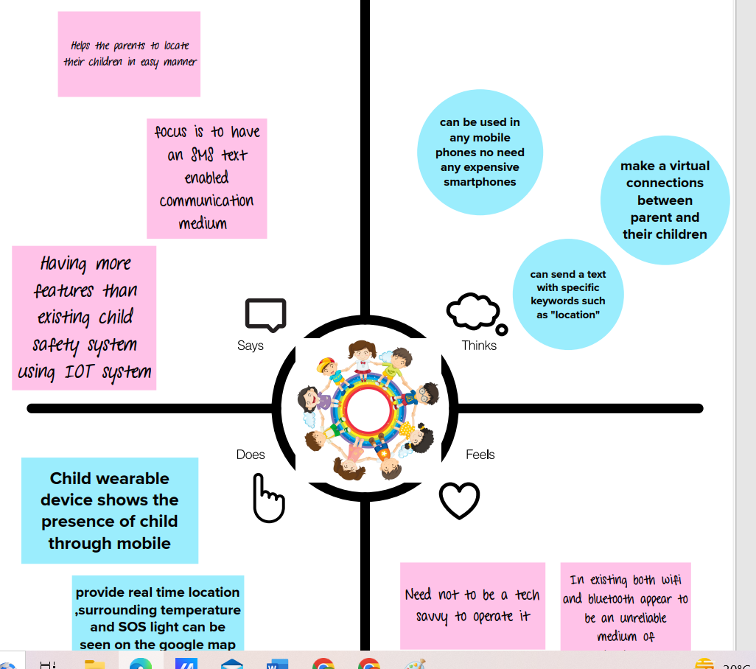

3.2 ideation & brainstorming

Ideation

Ideation is the creative process of generating, developing, and communicating new ideas, where an idea is understood as a basic element of thought that can be either visual, concrete, or abstract. Ideation comprises all stages of a thought cycle, from innovation, to development, to actualization.

Brainstroming:

Brainstorming is a group creativity technique by which efforts are made to find a conclusion for a specific problem by gathering a list of ideas spontaneously contributed by its members.

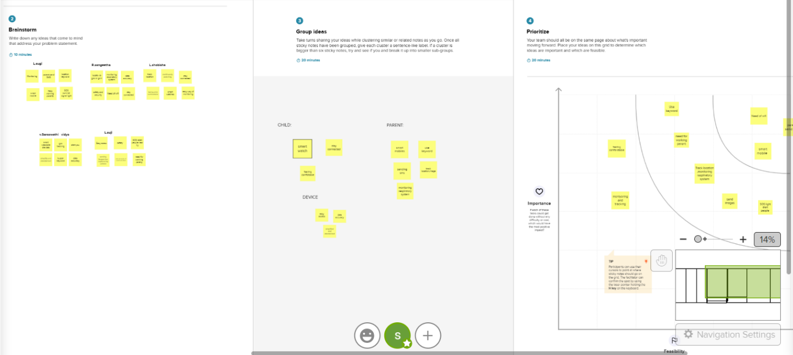

Keypoints

1.Brainstorm a long list of criteria. ...

2. Pick the 5 most important criteria. ..

3. Define each criterion. ...

4. Criterion: 'PROFITABILITY' ...

5. Final check. ...

6. Create a shortlist. ...

7. Note the shortlist on a flip chart. ...

8. Hand out the criteria.

3.3 proposed solution

The proposed solution of smart band An IoT based wearable smart band for children is proposed in this research for child security purposes.

The smart band is waterproof, chargeable and equipped with sensors. Heart rate sensor measures pulse rate and BPM. Sleep quality sensor obtains children’s sleep quality, cycle and positions.

Altimeter detects changes in height and sense whether children are going down a slope or climbing stairs, thereby measuring calorie count.

On theother hand, pedometer is used for counting steps. The motion sensor is applied to determines whether children are jogging or running.

Blood pressure sensor used to measure blood pressure.

In addition, the respiratory rate sensor detects breathing patterns and respiratory rate.

Furthermore, the temperature sensor is used to detect body temperature. Besides, by using the emotion detector the emotional state, pressure and anxiety levels can be gained.

Apart from that, this smart band contains GPS for tracking, identifying children’s location and setting geofences.

Via the smart band, children can also contact parents. Emergency button, a feature in which will automatically record video and automatically call 4 emergency contacts when it is pressed.

An alert message along with the video clip is sent to parents’ devices.

The alarm and SOS light will be activated by parents through their devices.

As the diagram shows, sensors are connected through the internet.

They detect and capture different kinds of data.

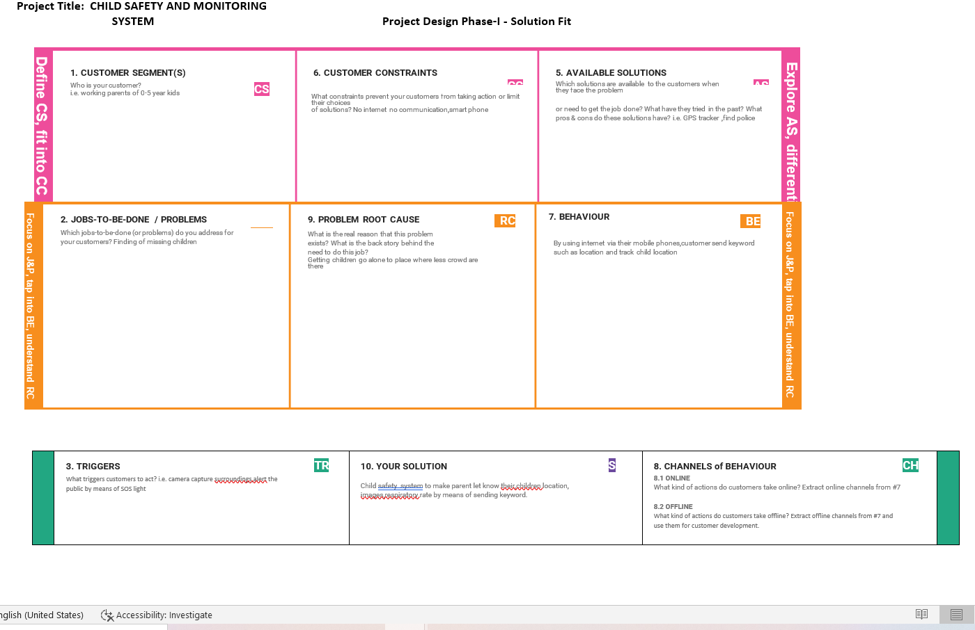

4.requirement analysis

Requirement analysis to register using their credentials to use the application. The device will be given to the children for monitoring them regularly. We will feed the boundary value while writing code for the system and we control it using GPS for that device which is also known as Geo Fencing.

4.1 functional requirement

We feed specific threshold values for sensors like temperature and pulse in which, if the device exceeds those threshold values or if the device gets exposed to abnormal condition then those values tend to be updated in the server. The server compares the currently obtained values with the coded threshold values, if they are beyond the threshold value, it generates an alert message through GSM. The alert messages are delivered to specified users in the form of SMS and the user can be able to login to the application to check the status and updated information.

Following are the functional requirements of proposed solution.

|  |  |  |
| --- | --- | --- |
| FR NO | FUNCTIONAL REQUIREMENT (epic) | Sub requirement (story/sub task) |
| FR-1 | User authentication | User must access to their mobile phones and communicate via sms mode |
| FR-2 | Send keyword | Parents send special keywords such as location , images, temperature keys |
| FR-3 | Geofence and cloudant DB | Via geofence system track and find real time location of the children and capture images surrounded by. |
| FR-4 | Alarm | By buzzering alarm make public alert and use SOS light |

4.2 non functional requirements

After receiving the alert messages, if the user wants to visually check the status of the child, they are required to enter specific IP address of that camera for the first time before syncing and can be able to watch the live streaming videos which are updated to the server, for further uses they can directly view. The microprocessor is used to control all these actions and the alert was done by checking for specific user of that device in the database.

Following are the non -functional requirements of the proposed solution.

|  |  |  |
| --- | --- | --- |
| NFR NO | Non functional requirement | Description |
| NFR-1 | Usability | Child safety and monitoring gadget help working parent to take care off their children by monitoring for the whole day and send SMS when they step into uncrowded or unsafety places. |
| NFR-2 | Security | For little children getting lost into major crowded areas .To  Reduce the risk this gadget is very useful |
| NFR-3 | Reliability | The prediction of values is accurate ,information from the device can be trusted by the customers without any uncertainity |
| NFR-4 | Performance | Immediate prediction of location, image , temperature .fast response time, easy to interact with the children, output can be rendered with in second |
| NFR-5 | Availability | Can be used in any cell phone does not require any expensive mobile phones |
|  |  |  |
| NFR-6 | Scalability | This system provide additional informations such as heart beat and monitoring the respiratory system of children. |

**5.project design**

5.1data flow diagrams

The Autonomous position detection and tracking system enhances the accuracy of locating friends and family member's positions by using GPS and standard web technology. This system includes a mobile client, a repository, a web client and a map service.

USER STORIES

|  |  |  |  |  |  |  |
| --- | --- | --- | --- | --- | --- | --- |
| USER TYPE | FUNCTIONAL REQUIREMENTS(EPIC) | USER STORY NUMBER | USER STORY/TASK | ACCEPTANCE CRITERIA | PRIORITY | RELEASE |
| CUSTOMER(WORKING PARENTS} | ACCESS TO INTERNET | USN-1 | IT IS DIFFICULT FOR THE WORKIMG PARENT TO MONITOR THE CHILDREN | Must wear GPS tracker and there should be proper internet | HIGH | SPRINT-1 |
| CUSTOMER(PARENTS HAVING 5-10 YEARS OLD CHILD) | ACCESS TO INTERNET | USN-2 | WHEN THEY STEP INTO THE UNSAFETY AREA IT WILL ALERT YOU | Must wear GPS tracker and there should be proper internet | HIGH | SPRINT-1 |
|  |  |  |  |  |  |  |

5.2 solution & technical architecture

SOLUTION ARCHITECTS

Solution Architects are most similar to project managers, ensuring that all parties, including stakeholders, are on the same page and moving in the right direction at all stages.

TECHNICAL ARCHITECTS

Technical architects manage all activities leading to the successful implementation of a new application.

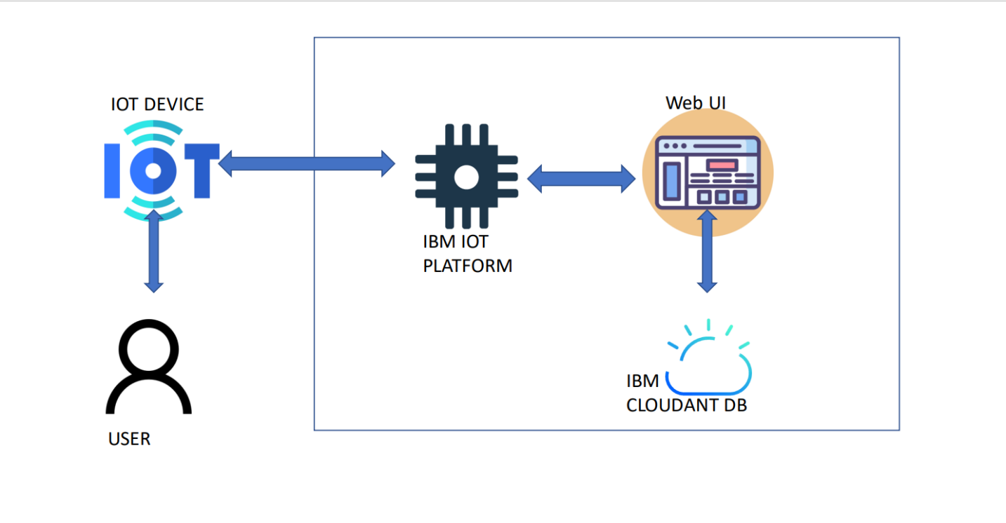5.3 user stories

TEAM ID:PNT2022TMID50962

TEAM SIZE: 5

TEAM LEADER :L.SUGI

TEAM MEMBER 2 : L.SHOBISHA

TEAM MEMBER 3: L.SUJI

TEAM MEMBER 4 : .R.SANGEETHA

TEAM MEMBER 5 : V.SARASWATHI VIDYA

6.project planning & scheduling

6.1 sprint planning & estimation

Sprint planning is an event in scrum that kicks off the sprint. The purpose of sprint planning is to define what can be delivered in the sprint and how that work will be achieved.

Sprint planning is done in collaboration with the whole scrum team.

**Creating and Connecting IBM cloud for Project and Python Code**

|  |  |
| --- | --- |
| **TITLE** | IOT based child safety gadget for child safety monitoring and notification |
| **DOMAIN NAME** | INTERNET OF THINGS |
| **TEAM ID** | PNT2022TMID50962 |
| **TEAM LEADERNAME** | SUGI.L |
| **TEAM MEMBER NAME** | SANGEETHA.R  SARASWATHI VIDYA  SHOBISHA  SUJI |
| **MENTOR NAME** | BARADWAJ |

**IBM Cloud Service and creating the device**

Visualize end-to-end cloud application performance in real time. Accelerate migration. Correlate performance to real user experiences. Start your free trial now. schedule a call back. schedule a demo. get free trial.

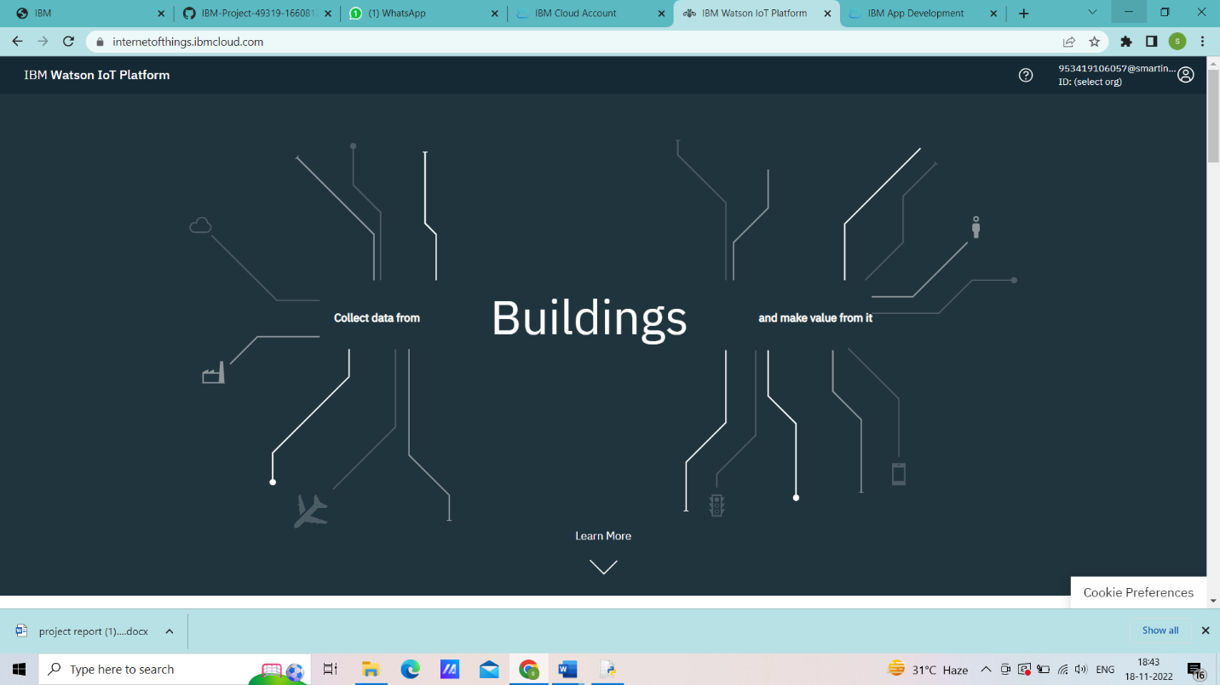

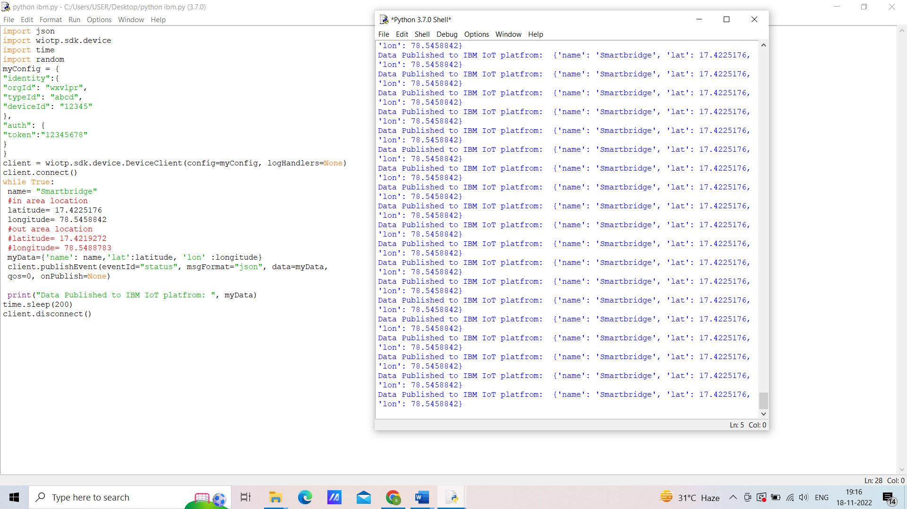

6.2 sprint planning & estimation

**Creating Cloudant DB and connecting to Node-Red Create App in MIT App inventor**

|  |  |
| --- | --- |
| **TITLE** | IOT based child safety gadget for child safety monitoring and notification |
| **DOMAIN NAME** | INTERNET OF THINGS |
| **TEAM ID** | PNT2022TMID50962 |
| **TEAM LEADERNAME** | SUGI.L |
| **TEAM MEMBER NAME** | SANGEETHA.R  SARASWATHI VIDYA  SHOBISHA  SUJI |
| **MENTOR NAME** | BARADWAJ |

CREATE CLOUDANT DB:

Cloudant is an IBM software product, which is primarily delivered as a cloud-based service.

Cloudant is a non-relational, distributed database service of the same name.

Cloudant is based on the Apache-backed CouchDB project and the open source BigCouch project.

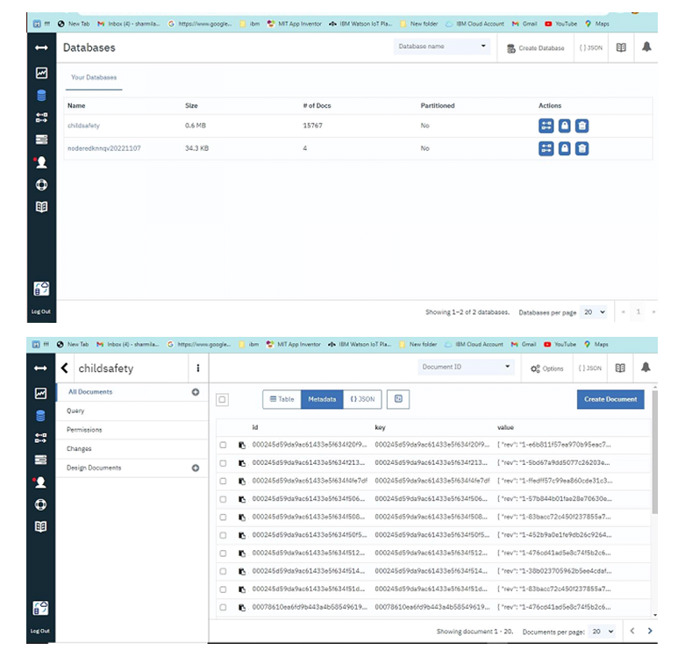

**Connecting the Node-Red Service and MIT app With Web UI and Show the child location and notify**

|  |  |
| --- | --- |
| **TITLE** | IOT based child safety gadget for child safety monitoring and notification |
| **DOMAIN NAME** | INTERNET OF THINGS |
| **TEAM ID** | PNT2022TMID49428 |
| **TEAM LEADERNAME** | SUGI.L |
| **TEAM MEMBER NAME** | SANGEETHA.R  SARASWATHI VIDYA  SHOBISHA  SUJI |
| **MENTOR NAME** | BARADWAJ |

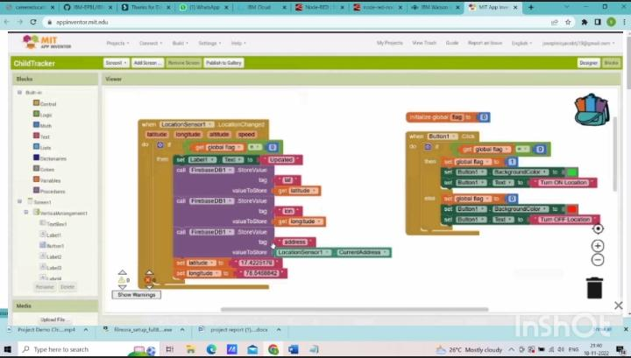

7.CODING & SOLUTIONING

Cloud computing is **the delivery of different services through the Internet, including data storage, servers, databases, networking, and software**. Cloud storage has grown increasingly popular among individuals who need larger storage space and for businesses seeking an efficient off-site data back-up solution.

Cloud solutions, also known as [cloud computing](https://susedefines.suse.com/definition/cloud-computing/) or cloud services, deliver IT resources on demand over the Internet. With cloud solutions, IT resources can [scale up or down quickly](https://susedefines.suse.com/definition/scalability/) to meet business demands. Cloud solutions enable rapid access to flexible and low-cost IT resources without large upfront investments in hardware or time-consuming installation and maintenance.

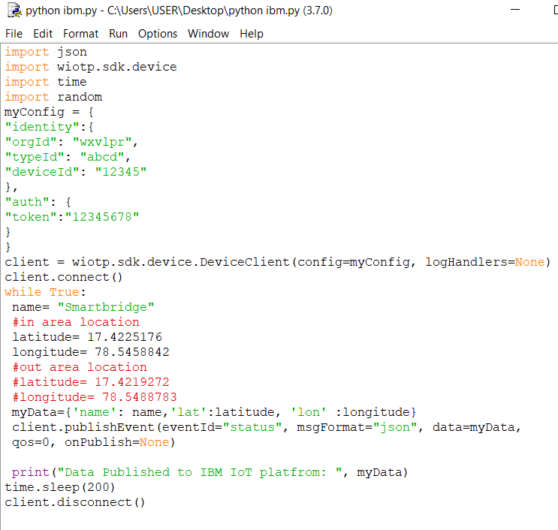

7.1 FEATURE

Child safety device is know for The LinkIt ONE board is an open source platform. It consists of inbuilt Wi-Fi, GSM, GPS and Bluetooth modules.

The link it one board is similar to the arduino board and it is termed as all-in-one prototyping board for wearable’s and IoT devices. The board consists of ARM7 EJ-S and the clock speed is 260MHz.

A SIM and SD card slots are provided on the board itself. For the audio purpose a headset slot is also provided. The link it one is a robust development board for the hardware and also used for industrial applications.

Different components such as Temperature sensor, Touch sensor, heartbeat sensor, GSM, GPS modules and serial camera are connected to the LinkIt ONE Board along with builtinGSM, GPS modules.

Lithium ion battery is used as DC supply required to energize it. A rechargeable battery can also be used for the above purpose. Temperature sensor block is shown in figure 1; temperature is one of the most commonly measured variables and is therefore there are many ways of sensing temperature.

For measuring body temperature of the child LM35 temperature sensor is used. The touch sensor has three main components on the circuit board.

The first component comprises of resistors, transistors, capacitors, inductors, and diodes whose area is measured physically and its analogue signal is sends to an amplifier. Depends upon the resistant value of the potentiometer the amplifier amplifies the signal and sends the signal to analogue output of the module.

The third component is comparator, when the signal falls under a specific value it is used to switch the output. A serial camera is used for the purpose of taking snapshot of the area surrounding the child.

A miniature TTL serial JPEG camera is used because it is the best one for the purpose of wearable type. The camera can snap the images of different sizes of pixels and those images are pre-compressed into JPEG images.

The heartbeat sensor is used in the proposed system for measuring the pulse rate. There is a heartbeat pulse sensor which is combined to simple optical heart rate sensor with amplification and nullification circuitry making it is fast and easy to get reliable pulse reading.

The GSM/GPRS block is activated with a SIM card on the board. GSM standard used here is GSM900. They mainly differ‘s based on bandwidth and RF carrier frequency.

GSM network consists of mobile station, Base station subsystem network and operation subsystem. The GPS module is provided for identifying the location of the child. GPS module receives the signals from satellites which are located miles away.

The latitude and longitude of the location can be identified by the GPS module. The Link it ONE board consists of micro SD/SIM combo.

The device sends the monitored parameters data such as Temperature, touch and pulse rate to cloud. When there are any abnormalities in temperature or touch or pulse rate readings, a SMS is sent to the parent/caretaker mobile phone immediately.

After sending SMS the serial camera captures the International Journal of Innovative Technology and Exploring Engineering (IJITEE) ISSN: 2278-3075, Volume-8 Issue-8 June, 2019 1793

Published By: Blue Eyes Intelligence Engineering Retrieval Number H6836058719/19©BEIESP & Sciences Publication snapshot in real time and is stored in SD card. From the SD card through the GSM module an MMS is sent to the particular mobile phone.

7.2 database schema

Child Health Monitoring Using Sensor Technology is a framework to support a unique health care for children. Using this framework the parents and other related persons who take care the child’s and keep intense monitoring on the children’s physical health condition from anywhere.

This framework also can be used to reduce or prevent things that can be harmful for children’s health, grow, and development progress. The CHC (Child Health Care) will be provides many features and such as notification and monitoring system to a professional health care of school as well as parent, based on the children (student) record.

This framework will improve the children’s health, grow and development progress.

With the rapid development of urbanization and industrialization in China, more and more children are studying and living in cities, which presents some safety challenges.

To help guardians better monitor their children, the authors present ChildGuard, a child safety system based on mobile devices. ChildGuard provides an in-path safety function that monitors the real-time movement of children walking on the road.

It also provides a region safety function that sets designated areas in which children can play. Children can be warned about potential risks, and their guardians can be informed of location or activity abnormities. Experiments show that ChildGuard has higher positioning accuracy and better real-time communication than similar systems. This article is part of a special issue on cybersecurity.

* To help guardians better monitor their children, the authors present ChildGuard, a child safety system based on mobile devices. ChildGuard provides an in-path safety function that monitors the real-time movement of children walking on the road. It also provides a region safety function that sets designated areas in which children can play.

8.Testing

8.1 test cases

Today in introduce universe of advanced innovation and worldwide figuring each individual is associated with each other in number of ways. In current worldwide figuring world, the youngsters and ladies provocation, chain snatchings, hijacking, lewd activities, eve prodding, and so forth are expanded step by step, winding up more perilous and powerless.

At the point when these risky circumstances happen there must be an inclining innovation to be agreeable to deal with. So we are proposing a framework that takes a shot at the debate of youngsters utilizing IOT.

In this venture we proposed a gadget which is incorporated with different gadgets, containing wearable "Action Tracker Wrist Band" which is modified with all the required information which incorporates the conduct of human Health is fundamental need and it is human right to get quality Health Care.

Nowadays India is facing many health issues because of less resource. This review paper presents the idea of solving health issues using latest technology, Internet of Things. It presents the architectural review of smart health care system using Internet of Things which is aimed to provide Quality Health Care to everyone.

Using this system architecture, patients' body parameters can be measure in real time. Sensors collects patients body parameters and transfers that data to Arduino Uno which further transfer that data to cloud with the help of WiFi module.

This data is stored into Thingspeak database server which manages data and provides accessibility. User can view this data with the help of Android App.

This work mainly focuses on alerting the individuals arround baby so as to locate the baby in safer zone before arrival of the parent. Among all the available wearable devices focusing on the conditions to provide the locality, action and so forth of the child to the parents via wireless Wi-Fi and Bluetooth, Bluetooth and Wi-Fi (wireless fidelity)becomes a very inconsistent resource to the communication.

Hence by the implementation of IOT technology it is planned to use SMS/MAIL as the method of communiqué between the parent and child wearable device.

9.Results

9.1 performance metrics

Performance metrics are defined as **figures and data representative of an organization's actions, abilities, and overall quality**.

Performance measurement is the process of collecting, analyzing and/or reporting information regarding the performance of an individual, group, organization, system or component .

Definitions of performance measurement tend to be predicated upon an assumption about why the performance is being measured.

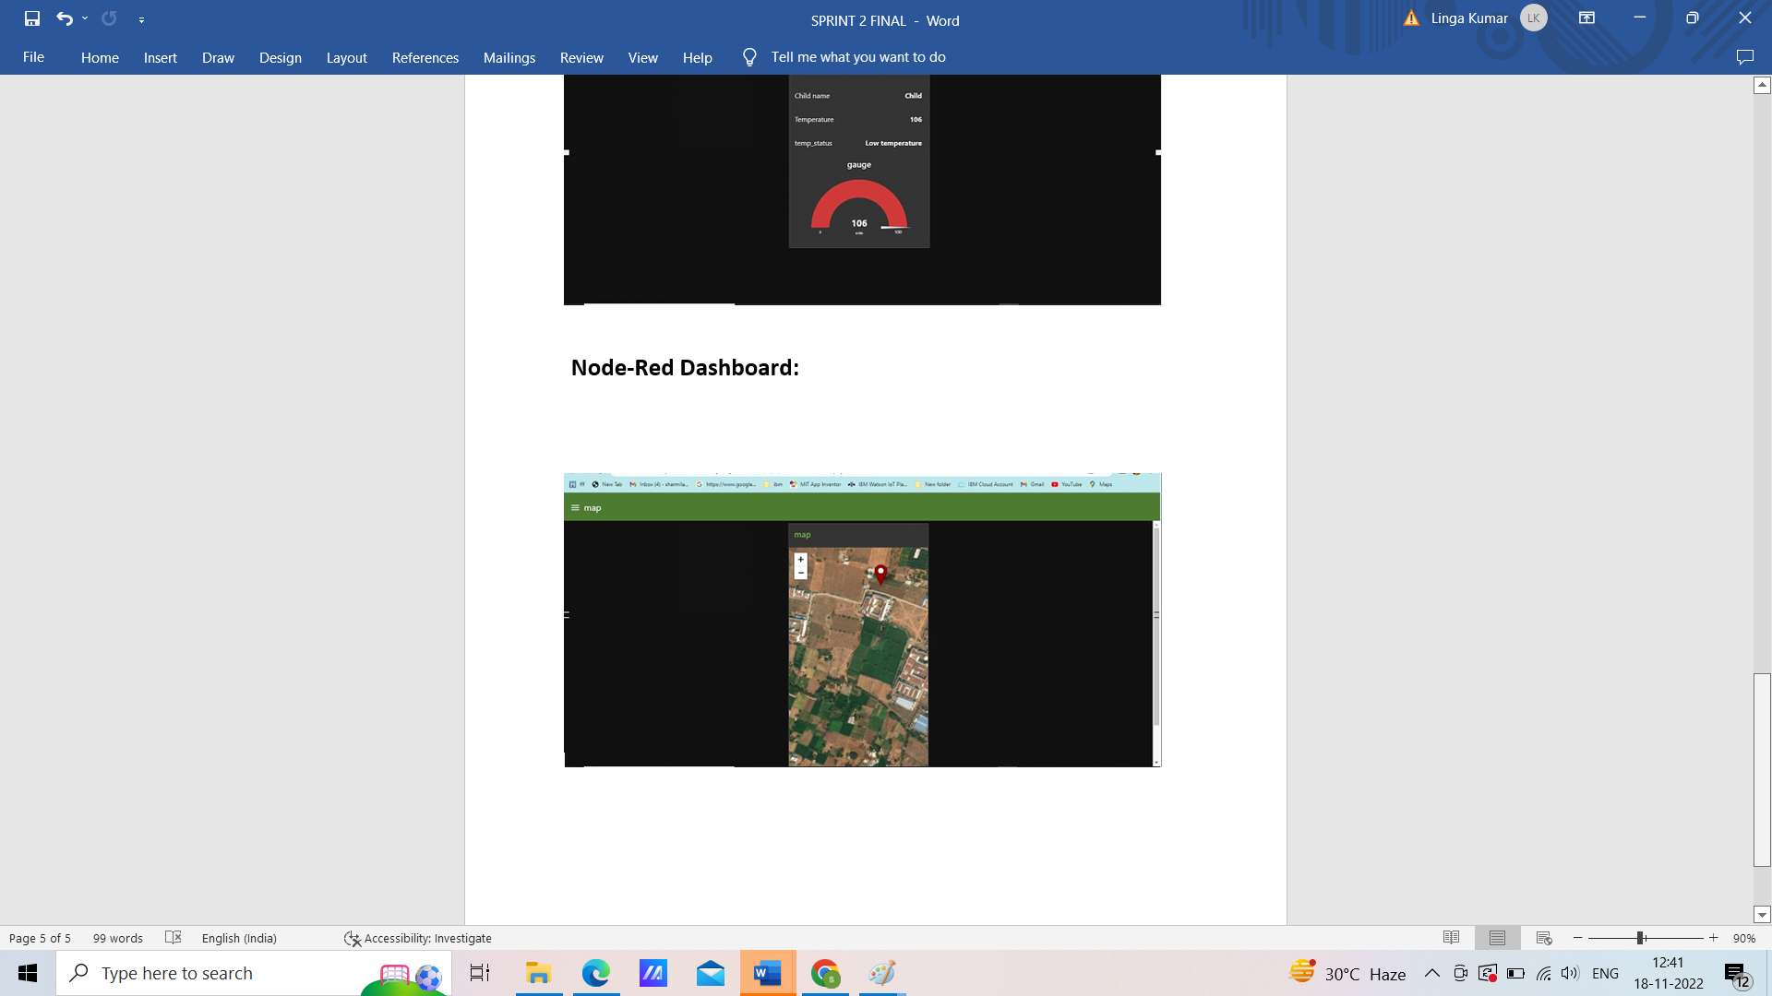

10.advantages and disadvantages

**Sometimes parents cannot reach a family-based arrangement about child maintenance. There might be no trust between you or other reasons that stop you agreeing child maintenance. Or you might prefer to involve the Child Maintenance Service (CMS) to assess and collect payments. CMS can also enforce a parent’s payments.**

| **Advantages** | **Disadvantages** |
| --- | --- |
| Using the Child Maintenance Service Direct Pay option is a free service. | There is a charge for the Child Maintenance Collect and Pay service. |
| This might be suitable if you have a strained relationship with the other parent. You may find it helpful for the Child Maintenance Service to collect and enforce the right level of maintenance to pay. | When people have a family-based arrangement, this can get money to the receiving parent more quickly. Also it can be easier to resolve breakdowns in payment when a third party is not involved. |
| If you don’t know where the other parent is, or they don’t want to accept responsibility, the Child Maintenance Service can try and trace them, assess payments, collect payments and enforce when they don’t pay. | Due to the formal process and the paperwork involved with Child Maintenance Service arrangements, it can take time to update these arrangements, for example when your circumstances change. |
| You don’t have to be in  contact with the other parent if you don’t want to, for example if there’s a history of abuse. | Once you ask the Child Maintenance Service to decide on how much maintenance to pay, you have to abide by their decision. It is not possible to ask the Child Maintenance Service to collect a different amount of maintenance other than what has been determined by their formula. |
| The amount of child maintenance will be set by the Child Maintenance Service. They will provide parents with the relevant payment or collection schedules to advise them of their payment information. | There is less flexibility about how and when you make and receive payments. Making special arrangements for things like summer holidays is more difficult with a Child Maintenance Service arrangement than with a family-based arrangement. The Child Maintenance Service uses a set formula to work out payments. |
| You can go back to a family-based arrangement in the future, if both parents agree. | You have to share your details with the Child Maintenance Service. With a family-based arrangement, you only have to share your details with the other parent. |
| If a parent won’t share their details, the Child Maintenance Service has the authority to get those details from other government bodies, or the parent's employer. | The more ‘legal’ things become, the harder it can be sometimes on your child and your relationship with the other parent. |

More useful links

* [Applying for child maintenance](https://www.nidirect.gov.uk/articles/applying-for-child-maintenance)
* [Making arrangements through the Child Maintenance Service](https://www.nidirect.gov.uk/information-and-services/child-maintenance-service/making-arrangements-through-child-maintenance)
* [Child Maintenance Choices](https://www.nidirect.gov.uk/contacts/contacts-az/child-maintenance-choices)
* [Calculate child maintenance](https://www.nidirect.gov.uk/articles/calculate-child-maintenance)

11.conclusion

This research demonstrates Smart IoT device for child safety and tracking helping the parents to locate and monitor their children.

If any abnormal values are read by the sensor then an SMS is sent to the parents mobile and an MMS .

The future scope of the work is to implement the IoT device which ensures the complete solution for child safety problems.